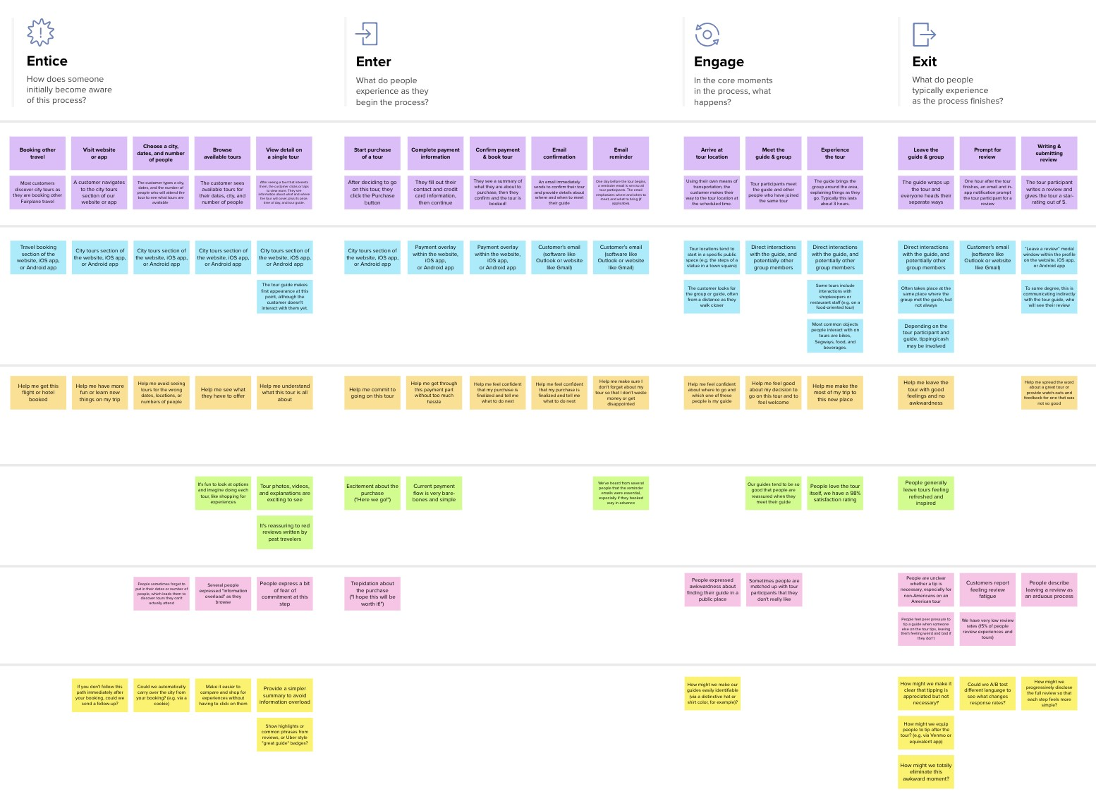

**Template**

**TIP**

As you add steps to the experience, move each these “Five Es” the left or right depending on the scenario you are documenting.

Customer experience journey map

**SCENARIO**

**Browsing, booking, attending, and rating a local city tour**

**Areas of opportunity**

How might we make each step better? What ideas do we have? What have others suggested?

**Negative moments**

What steps does a typical person find frustrating, confusing, angering, costly, or time-consuming?

**Positive moments**

What steps does a typical person find enjoyable, productive, fun, motivating, delightful, or exciting?

**Goals & motivations**

At each step, what is a person’s primary goal or motivation? (“Help me...” or “Help me avoid...”)

**Interactions**

What interactions do they have at each step along the way?

**People:** Who do they see or talk to?

**Places:** Where are they?

**Things:** What digital touchpoints or physical objects would they use?

**Steps**

What does the person (or group) typically experience?

people may find looking at their monthly credit or debit card

everyday routine to make people manage their money

**understanding that you spend money on and how much you spend**

**getting your finances in order**

Use this framework to better understand customer needs, motivations, and obstacles by illustrating a key scenario or process from start to finish.

people find their monthly debit or credit card details

keeping track of your expenses

giving good idea of uour purchasing behaviour

When possible, use this map to document and summarize interviews and observations with real people rather than relying on your hunches or assumptions.

categorize your spending so you can better understand your purchasing habits.

can save you time instead of you having to manually gather all your different credit card statements and such

# Created in partnership with

System takes Income from House-Wife and divides in daily expense allowed

you have to pay for those tools.

a budget makes it easier

## to pay bills on time, build

an emergency fund, and

Tracking your spending puts your money on record so you know where you stand in your finances.

## save for major expenses

such as a car or home.

[**Share template feedback**](https://muralco.typeform.com/to/CiqaHVat?typeform-source=app.mural.co)

**Need some inspiration?**

See a finished version of this template to kickstart your work.

[**Open example**](https://app.mural.co/template/f59f644b-b4b4-47b5-9ed6-3a8c71ceb612/896b31fe-5597-40ef-9b06-3811a1a45ace)